

**Name: Inshirah Hassan**

**Reg NO. B22F0064SE112**

**Software Construction and Development**

**Lab Report 1**

**Tasks:**

**Task 1:**

1. Write a Java program to convert temperature from Fahrenheit to Celsius degrees.

Code:

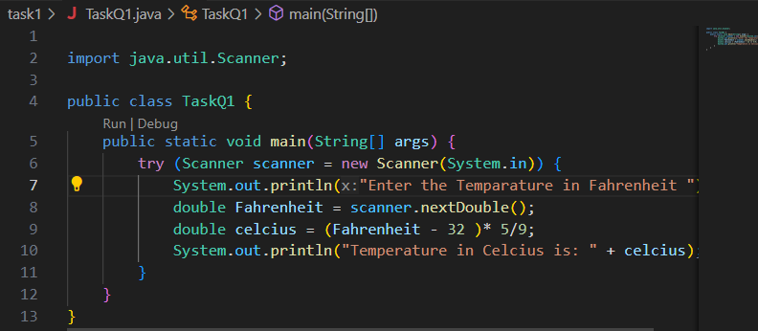

Output:

**Task 2:**

1. Write a Java program to convert inches into meters.

Code:

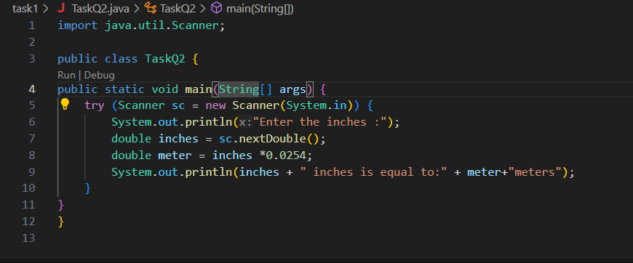

Output:

**Task 3:**

1. Write a Java program to meters into kilometers.

Code:

Output:

**Task 4:**

1. Write a Java program to convert minutes into years and days.

Code:

Output:

**Task 5:**

1. Write a Java program to print ranges of all primitive data types.

Code:

Output:

